HCMC UNIVERSITY OF TECHNOLOGY & ENGINEERING  FACULTY OF HIGH QUALITY TRAINING |  | ENGLISH 2  End-of-term Test  Code: EHQT130237  Semester: 2  School year: 2025-2026  Date: 24/4/2026  Duration: 60 minutes.  Questions: 60  Pages: 9
Invigilator 1 | Invigilator 2
Marker 1 | Marker 2
Raw score: | Raw score:
Converted score | Converted score | Student’s name:  Student ID No.:  Ordinal No.: Room:
No materials are allowed.

Hướng dẫn đánh trắc nghiệm:

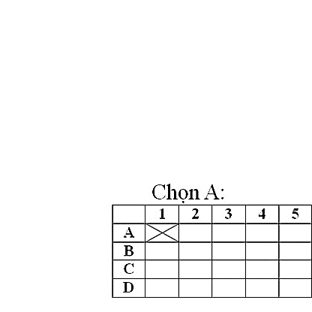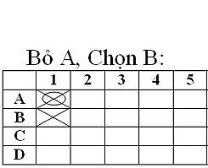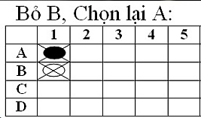

ANSWER SHEET

 | 1 | 2 | 3 | 4 | 5 | 6 | 7 | 8 | 9 | 10 | 11 | 12 | 13 | 14 | 15 | 16 | 17 | 18 | 19 | 20
A
B
C
D

 | 21 | 22 | 23 | 24 | 25 | 26 | 27 | 28 | 29 | 30 | 31 | 32 | 33 | 34 | 35 | 36 | 37 | 38 | 39 | 40
A
B
C
D

 | 41 | 42 | 43 | 44 | 45 | 46 | 47 | 48 | 49 | 50 | 51 | 52 | 53 | 54 | 55 | 56 | 57 | 58 | 59 | 60
A
B
C
D

Raw score | Converted score |  | Raw score | Converted score
1 | 0 |  | 32-34 | 5.5
2-4 | 0.5 |  | 35-37 | 6
5-7 | 1 |  | 38-40 | 6.5
8-10 | 1.5 |  | 41-43 | 7
11-13 | 2 |  | 44-46 | 7.5
14-16 | 2.5 |  | 47-49 | 8
17-19 | 3 |  | 50-52 | 8.5
20-22 | 3.5 |  | 53-55 | 9
23-25 | 4 |  | 56-58 | 9.5
26-28 | 4.5 |  | 59-60 | 10
29-31 | 5

