HCMC UNIVERSITY OF TECHNOLOGY & ENGINEERING  FACULTY OF FOREIGN LANGUAGES  DEPARTMENT OF BUSINESS ENGLISH |  | END-OF-TERM TEST  English for Mechanical Engineering (ENME330437)  Date of test: 16/04/2026  The paper has 55 questions, on 8 pages.  Duration: 60 minutes.  No material is allowed. The test paper is submitted together with the answer sheet.
Invigilator 1 | Invigilator 2
Marker 1 | Marker 2
Raw score: | Raw score:
Converted score | Converted score | Student’s name:  Student ID No.:  Ordinal No.: …….Room:

ANSWER SHEET

SECTION 1. Questions 1-30
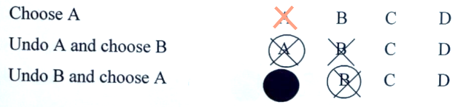

1 | A | B | C | D | 11 | A | B | C | D | 21 | A | B | C | D
2 | A | B | C | D | 12 | A | B | C | D | 22 | A | B | C | D
3 | A | B | C | D | 13 | A | B | C | D | 23 | A | B | C | D
4 | A | B | C | D | 14 | A | B | C | D | 24 | A | B | C | D
5 | A | B | C | D | 15 | A | B | C | D | 25 | A | B | C | D
6 | A | B | C | D | 16 | A | B | C | D | 26 | A | B | C | D
7 | A | B | C | D | 17 | A | B | C | D | 27 | A | B | C | D
8 | A | B | C | D | 18 | A | B | C | D | 28 | A | B | C | D
9 | A | B | C | D | 19 | A | B | C | D | 29 | A | B | C | D
10 | A | B | C | D | 20 | A | B | C | D | 30 | A | B | C | D

SECTION 2 & 3. Questions 31-50

31 | buoyancy | 41 | smelting
32 | equilibrium | 42 | uniform composition
33 | matter | 43 | wrought iron
34 | gravity | 44 | stainless steel
35 | newtons | 45 | China
36 | elasticity | 46 | False
37 | friction | 47 | True
38 | heat | 48 | False
39 | reaction | 49 | Not given
40 | rolling | 50 | True

Section 4. Translation
………………………………………………………………………………………………………………………………………………………………………………………………………………………………………………………………………………………………………………………………………………………………………………………………………………………………………………………………………………………………………………………………………………………………………………………………………………………………………………………………………………………………………………………………………………………………………………………………………………………………………………………………………………………………………………………………………………………………………………………………………………………………………………………………………………………………………………………………………………………………………………………………………………………………………………………………………………………………………………………………………………………………………………………………………………………………………………………………………………………………………………………………………………………………………………………………………………………………………………………………………………………………………………………………………………………………………………………………………………………………………………………………………………………………………………………………………………………………………………………………………………………………………………………………………………………………………………………………………………………………………………………………………………………………………………………………………………………………………………………………………………………………………………………………………………………………………………………………………………………………………………………………………………………………………………………………………………………………………………………………………………………………………………………………………………………………………………………………………………………………………………………………………………………………………………………………

