HCMC UNIVERSITY OF TECHNOLOGY & EDUCATION  FACULTY OF FOREIGN LANGUAGES |  | FINAL TEST OF ENGLISH 3 (EHQT230337)  TERM I – SCHOOL YEAR: 2024-2025  Test date: 02/01/2025  The paper has 60 questions, on 10 pages.  Duration: 60 minutes.  No materials are allowed.
Invigilator 1 | Invigilator 2
Examiner 1 | Examiner 2
Raw score: | Raw score:
Converted score | Converted score | Student’s name:  Student ID No. (MSSV):  Ordinal No. (STT): ………..Room:

Hướng dẫn đánh trắc nghiệm | 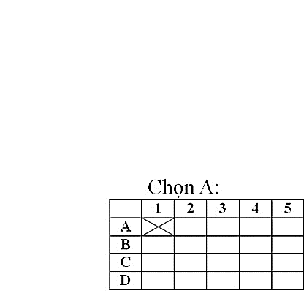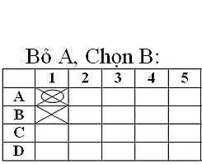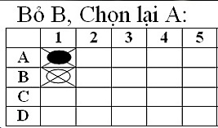

ANSWER SHEET

 | 1 | 2 | 3 | 4 | 5 | 6 | 7 | 8 | 9 | 10 | 11 | 12 | 13 | 14 | 15 | 16 | 17 | 18 | 19 | 20
A
B
C
D

 | 21 | 22 | 23 | 24 | 25 | 26 | 27 | 28 | 29 | 30 | 31 | 32 | 33 | 34 | 35 | 36 | 37 | 38 | 39 | 40
A
B
C
D

 | 41 | 42 | 43 | 44 | 45 | 46 | 47 | 48 | 49 | 50 | 51 | 52 | 53 | 54 | 55 | 56 | 57 | 58 | 59 | 60
A
B
C
D

