|  |  |  |
| --- | --- | --- |
| HCMC UNIVERSITY OF TECHNOLOGY & EDUCATION **FACULTY OF FOREIGN LANGUAGES** | | **FINAL TEST OF ENGLISH 1**  **(**EHQT130137**)**  **TERM I – SCHOOL YEAR: 2024-2025**  Date of test: **27/12/2024**  The paper has **60** questions, on **08** pages.  Duration: **60** minutes.  **No materials are allowed.** |
| Invigilator 1’s signature | Invigilator 2’s signature |
| Examiner 1 | Examiner 2 |
| Raw score: | Raw score: |
| **Converted score** | **Converted score** | **Student’s name:**  **Student ID No. (MSSV):**  **Ordinal No. (STT):** ………..**Room:** |
|  |  |

**Hướng dẫn đánh trắc nghiệm:**

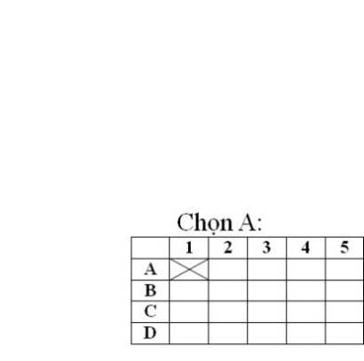 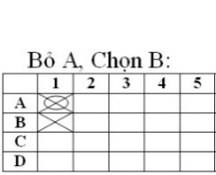 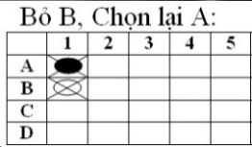

**ANSWER SHEET**

|  |  |  |  |  |  |  |  |  |  |  |  |  |  |  |  |  |  |  |  |  |
| --- | --- | --- | --- | --- | --- | --- | --- | --- | --- | --- | --- | --- | --- | --- | --- | --- | --- | --- | --- | --- |
|  | **1** | **2** | **3** | **4** | **5** | **6** | **7** | **8** | **9** | **10** | **11** | **12** | **13** | **14** | **15** | **16** | **17** | **18** | **19** | **20** |
| **A** |  |  |  |  |  |  |  |  |  |  |  |  |  |  |  |  |  |  |  |  |
| **B** |  |  |  |  |  |  |  |  |  |  |  |  |  |  |  |  |  |  |  |  |
| **C** |  |  |  |  |  |  |  |  |  |  |  |  |  |  |  |  |  |  |  |  |
| **D** |  |  |  |  |  |  |  |  |  |  |  |  |  |  |  |  |  |  |  |  |

|  |  |  |  |  |  |  |  |  |  |  |  |  |  |  |  |  |  |  |  |  |
| --- | --- | --- | --- | --- | --- | --- | --- | --- | --- | --- | --- | --- | --- | --- | --- | --- | --- | --- | --- | --- |
|  | **21** | **22** | **23** | **24** | **25** | **26** | **27** | **28** | **29** | **30** | **31** | **32** | **33** | **34** | **35** | **36** | **37** | **38** | **39** | **40** |
| **A** |  |  |  |  |  |  |  |  |  |  |  |  |  |  |  |  |  |  |  |  |
| **B** |  |  |  |  |  |  |  |  |  |  |  |  |  |  |  |  |  |  |  |  |
| **C** |  |  |  |  |  |  |  |  |  |  |  |  |  |  |  |  |  |  |  |  |
| **D** |  |  |  |  |  |  |  |  |  |  |  |  |  |  |  |  |  |  |  |  |

|  |  |  |  |  |  |  |  |  |  |  |  |  |  |  |  |  |  |  |  |  |
| --- | --- | --- | --- | --- | --- | --- | --- | --- | --- | --- | --- | --- | --- | --- | --- | --- | --- | --- | --- | --- |
|  | **41** | **42** | **43** | **44** | **45** | **46** | **47** | **48** | **49** | **50** | **51** | **52** | **53** | **54** | **55** | **56** | **57** | **58** | **59** | **60** |
| **A** |  |  |  |  |  |  |  |  |  |  |  |  |  |  |  |  |  |  |  |  |
| **B** |  |  |  |  |  |  |  |  |  |  |  |  |  |  |  |  |  |  |  |  |
| **C** |  |  |  |  |  |  |  |  |  |  |  |  |  |  |  |  |  |  |  |  |
| **D** |  |  |  |  |  |  |  |  |  |  |  |  |  |  |  |  |  |  |  |  |