HCMC UNIVERSITY OF  TECHNOLOGY & EDUCATION  FACULTY OF FOREIGN LANGUAGES |  | FINAL TEST OF ENGLISH 4  (ENGL430437)  TERM III – SCHOOL YEAR: 2023 - 2024  Date of test: 24/07/2024  The paper has 100 questions, on 20 pages.  Duration: 75 minutes.  No materials are allowed
Invigilator 1 | Invigilator 2
Marker 1 | Marker 2
Raw score: | Raw score:
Converted score | Converted score | Student’s name:  Student ID No.:  Ordinal No.: Room:
Hướng dẫn đánh trắc nghiệm | 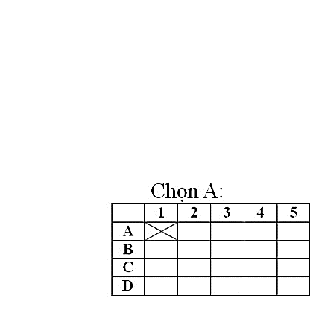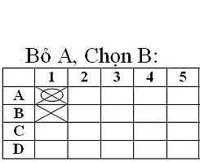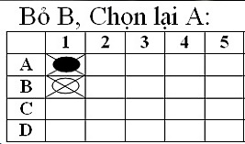
ANSWER SHEET
 | 1 | 2 | 3 | 4 | 5 | 6 | 7 | 8 | 9 | 10 | 11 | 12 | 13 | 14 | 15 | 16 | 17 | 18 | 19 | 20
A
B
C
D

 | 21 | 22 | 23 | 24 | 25 | 26 | 27 | 28 | 29 | 30 | 31 | 32 | 33 | 34 | 35 | 36 | 37 | 38 | 39 | 40
A
B
C
D

 | 41 | 42 | 43 | 44 | 45 | 46 | 47 | 48 | 49 | 50 | 51 | 52 | 53 | 54 | 55 | 56 | 57 | 58 | 59 | 60
A
B
C
D

 | 61 | 62 | 63 | 64 | 65 | 66 | 67 | 68 | 69 | 70 | 71 | 72 | 73 | 74 | 75 | 76 | 77 | 78 | 79 | 80
A
B
C
D

 | 81 | 82 | 83 | 84 | 85 | 86 | 87 | 88 | 89 | 90 | 91 | 92 | 93 | 94 | 95 | 96 | 97 | 98 | 99 | 100
A
B
C
D

