HCMC UNIVERSITY OF TECHNOLOGY AND EDUCATION  FACULTY OF FOREIGN LANGUAGES  Section of Language Skills |  | ENGLISH MORPHOLOGY AND SYNTAX  FINAL TEST – SEMESTER I  ACADEMIC YEAR: 2023-2024  Test Date: December 14, 2023  Course code: MOSY230236/MOSY230136  Duration: 75 minutes  No materials are allowed.
Invigilator 1 | Invigilator 2
Mark and Signature
Examiner 1 | Examiner 2 | Student’s name: ………………………………...  Student’s ID: ………………………………........  Ordinal number: …………… Room: …………
ANSWER KEY
PART I -- MORPHOLOGY
QUESTION 1 (10 marks)
1. | Onomatopoeia  (Echoism /Sound imitation) | 6. | Blending  /Clipping (acceptable)
2. | (full)* Conversion  (Word class shift) | 7. | Derivation  (Affixation /Suffixation)
3. | Compounding | 8. | Compounding
4. | Conversion (+stress shift)*  (Word class shift) | 9. | Acronymy
5. | Back-formation | 10. | Antonomasia
(full)* = optional
QUESTION 2 (10 marks)
Unzippable  unzip +‎ -able.  Interpretation: able to be unzipped | Unzippable  un- +‎ zippable.  Interpretation: not able to be zipped
or: (modified tree diagrams)
Interpretation 1: able to be unzipped
UN | ZIP(P) | ABLE
Interpretation 2: not able to be zipped
UN | ZIP(P) | ABLE

QUESTION 3 (10 marks)
1. | various | 6. | official
2. | historical | 7. | independence
3. | cultural | 8. | administration
4. | settlers | 9. | international
5. | expansion | 10. | organization

PART II -- SYNTAX
QUESTION 1 (10 marks)
1. | NP [iO] | 6. | PP [PC (prepositional complement of ‘depend’)*]
2. | PP [Complement of A (‘full’)*] | 7. | PP [oP/oC]
3. | NP [Subject] | 8. | AdvP [dA]
4. | PP [sP/sC] | 9. | AdvP [aA (of manner)*]
5. | NP [Post-MOD of ‘lady’]  /[Post-nominal modifier] | 10. | AdvP [cA /sA (Sentence-adverbial / S-adverbial)]
QUESTION 2 (10 marks)
1. | [dO] | 6. | [Adjective Complement/  Complement of A (‘sure’)*]
2. | [(post)*-MOD /post-modifier] | 7. | Extraposed Subject
3. | [aA (of reason)*] | 8. | [aA (of time)*]
4. | [(post)*-MOD /post-modifier] | 9. | [sP/sC]
5. | [noun complement /complement of ‘belief’  /(appositive post-modifier of ‘belief’)] | 10. | [S/Subject]
QUESTION 3 (10 marks)
- Noodles in spicy chicken broth (ambiguous)
- Noodles are in a broth which contains spicy chicken

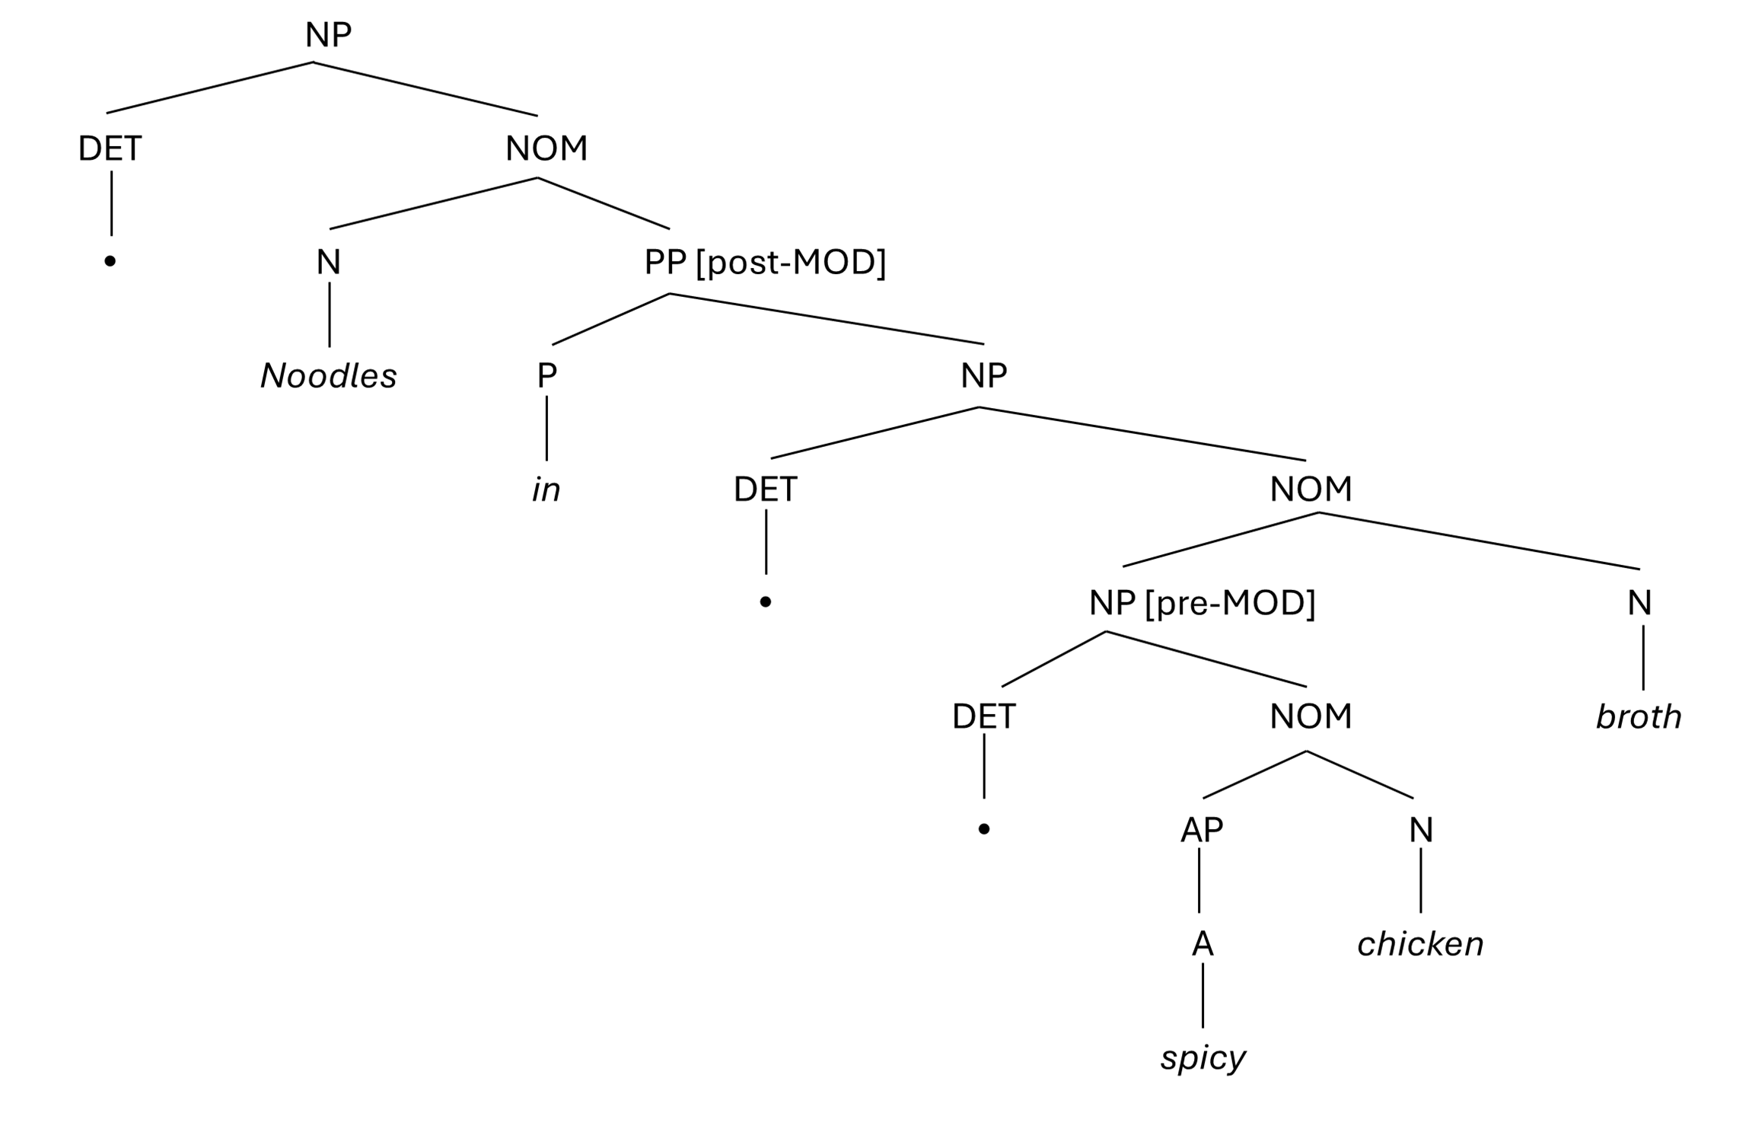
- Noodles are in a spicy broth which contains chicken

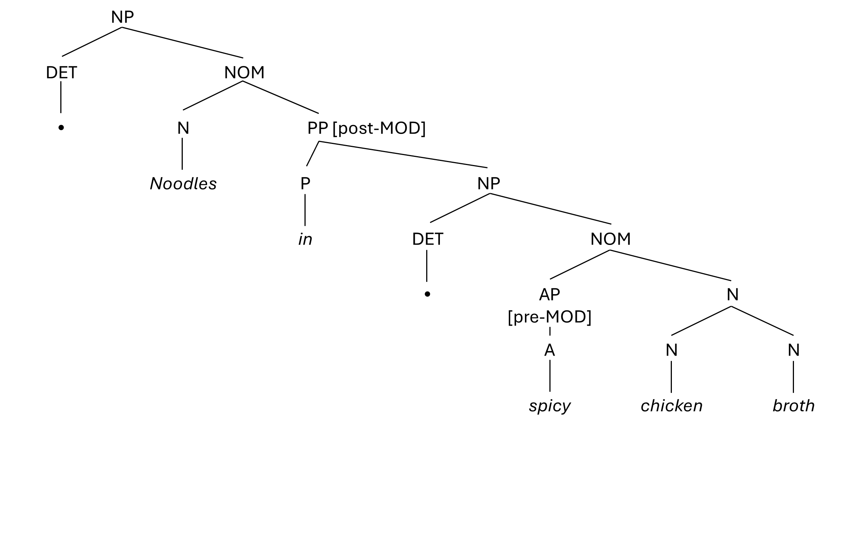

2. She gave her husband a new watch for his birthday.
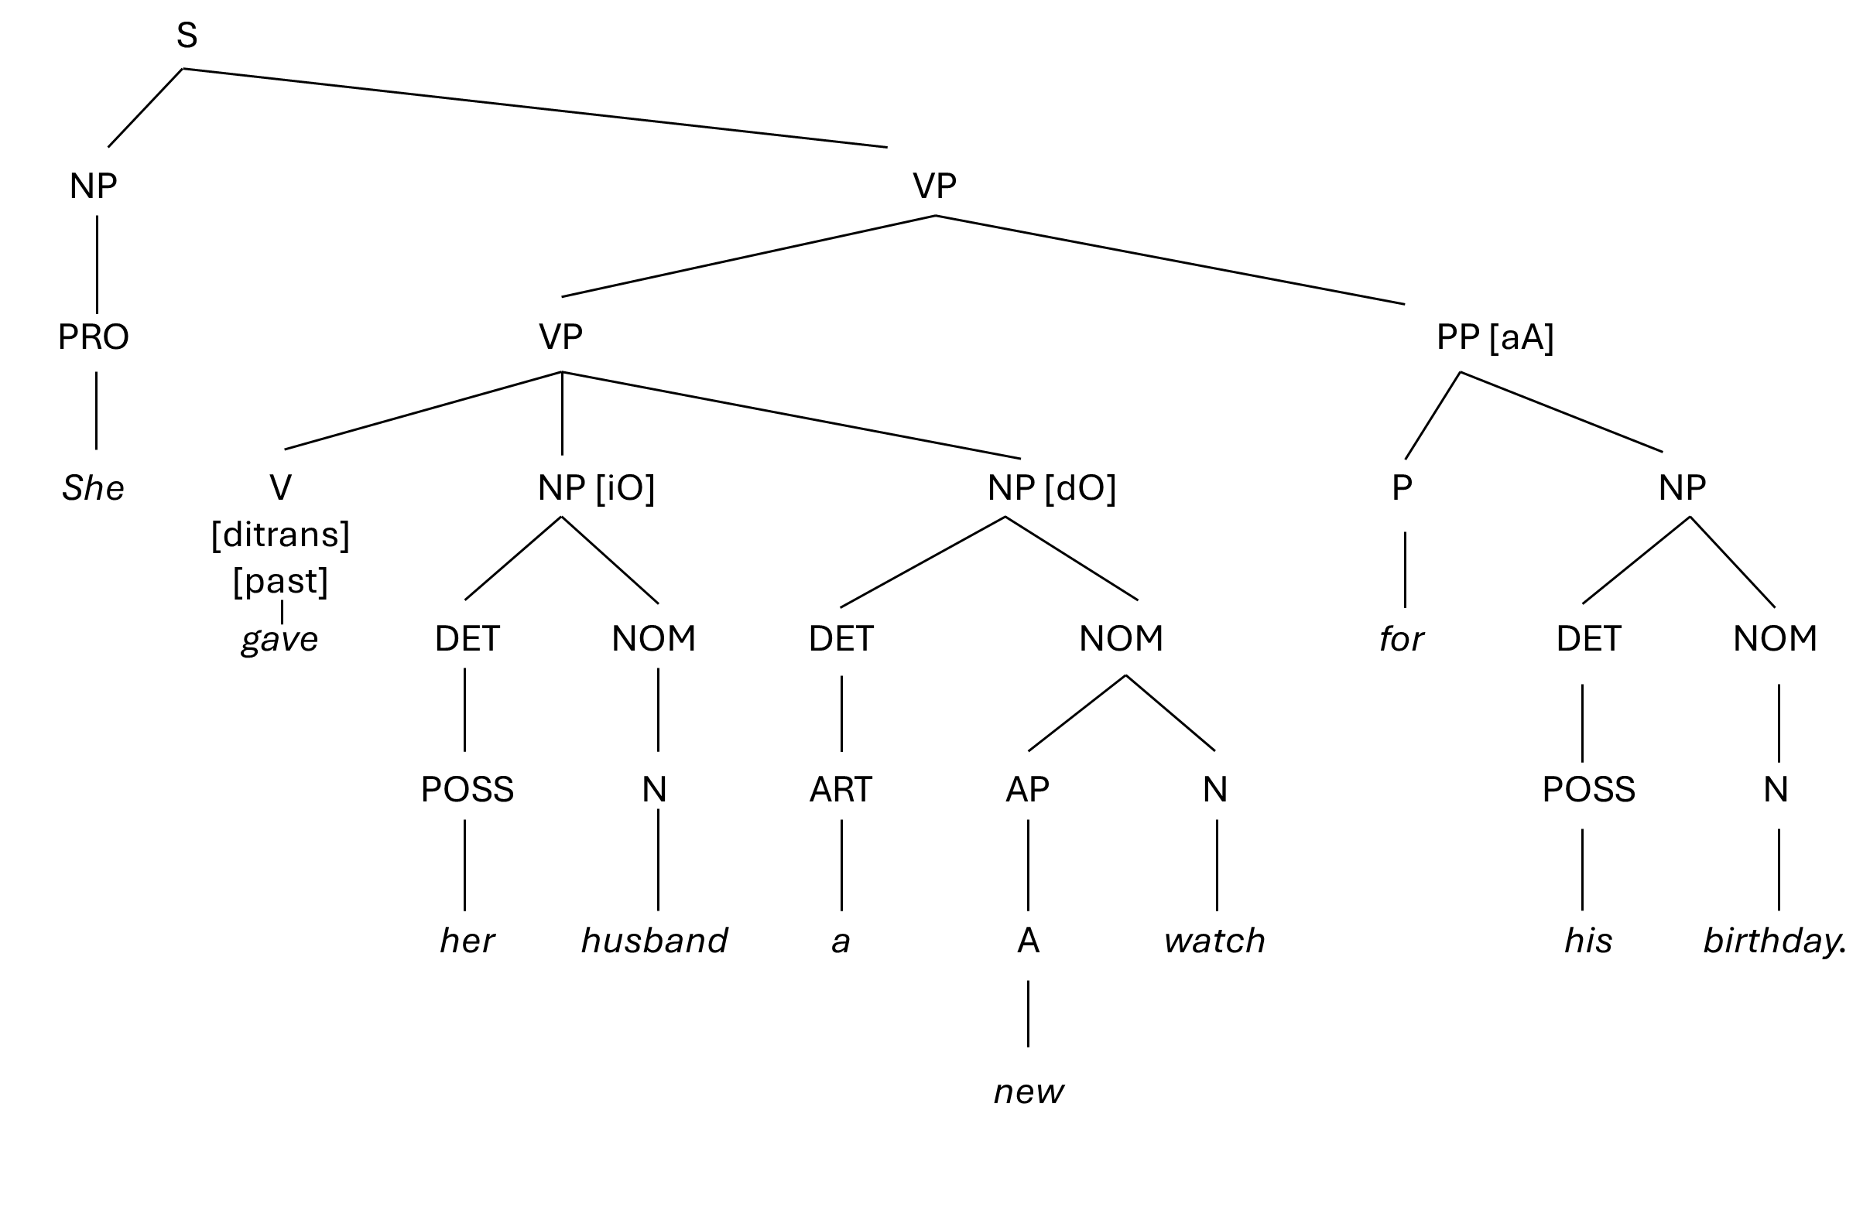

3. English is the main language, but many others are important.
